The VISION 360 BUSINESS SCHOLARSHIP is an annual scholarship program designed to provide an innovative regional business with a range of customised high quality core business tools, accounting support and financial guidance for 12 months, establishing a strong foundation on which the business can build an exciting future.
Each year the Panorama Business & Financial VISION 360 BUSINESS SCHOLARSHIP will focus attention on a particular interest group, industry sector or business niche, with the overarching aim of doing our part to proactively develop regional business, support positive life/work balanced business growth and nurture exceptional business initiatives that demonstrate a vested interest in regional NSW.
The VISION 360 BUSINESS SCHOLARSHIP focus for 2020:
Women in Business

THE STORY BEHIND the scholarship 2020 focus
We are passionate about equality. We want to show how committed we are in supporting our local business community by offering a full package service for 12 months to one local emerging female led business. We are strong believers that women in business make business better, and because of the lack of women in key leadership positions in Australian business, we are committed to changing this dynamic.

SCHOLARSHIP INCLUSIONS
VISION 360 is a platinum level scholarship program that provides the selected business with the following exceptional services across a 12 month period:
- Bookkeeping
- Payroll administration
- BAS preparation and lodgment
- Financial reports and cash flow management advice
- Tax return lodgment for business owner(s) and entity(ies)
- Goal setting and Human Resource assistance
- Tax planning and management of all Australian Tax Office obligations
- Management reporting of key performances indicators, including business coaching to identify key drivers of success and the establishment of an ongoing, bespoke reporting framework
- Business risk assessment including review of strategic, structural, and operational risks
- Business valuation at start and finish of engagement
- Asset protection review
- Insurance review for business and key stakeholders
The successful applicant will be partnered with different members of the PB&F team to ensure the business experiences the expertise our team has to offer in every field.

Application process
APPLICATIONS OPEN: WEDNESDAY 21ST OCTOBER 2020, 9AM
APPLICATIONS CLOSE: TUESDAY 10TH NOVEMBER 2020, 4PM
Applicants must:
- Complete the VISION 360 BUSINESS SCHOLARSHIP application form.
- Record a 30-90 second video explaining:
  - why you are the right candidate for this scholarship
  - what you aim to achieve in your business in the coming 12 months
- Submit the completed application form and the video introduction no later than 4pm Tuesday 10th November, to
VISION 360 BUSINESS SCHOLARSHIP PROGRAM COORDINATOR
E: admin@pbandf.com.au
A: 127 Keppel Street, Bathurst, NSW 2795
Short listed candidates will be contacted and required to participate in a 45-minute interview process to match your application against the selection criteria.
All short-listed candidates will be notified by email of the final outcome of their application process after all interviews have been completed. One applicant will be notified of their successful application and receipt of the scholarship.

Selection criteria

NEED
For 2020, an applicant business must:
- Be based in the Bathurst Region Local Government Area
- Have been in operation for less than 5 years
- Be a female led business.

Desirable
We are looking for applicants who are:
- Ambitious
- Ready and able to engage in all services offered by the scholarship opportunity, with a desire to gain clarity on business performance, to set goals and create an action plan to achieve those goals.

Conditions of the SCHOLARSHIP:
On accepting the scholarship the recipient agrees to be:
- Proactive and responsive to the services offered through the scholarship
- Willing to provide the required information to capture a panoramic view of your business
- Open to sharing the story of your progress through the sponsorship year. We anticipate sharing some progress stories through our social media platforms and envisage this will help with your accompanying marketing. We agree to provide the scholarship recipient with the opportunity to review any postings before they are made public.
The decision on the successful scholarship recipient is made by Panorama Business and Financial, and is final and binding and no correspondence will be entered into.
The scholarship inclusions are as stated, and no cash or other alternatives will be offered.
The scholarship is not transferable.
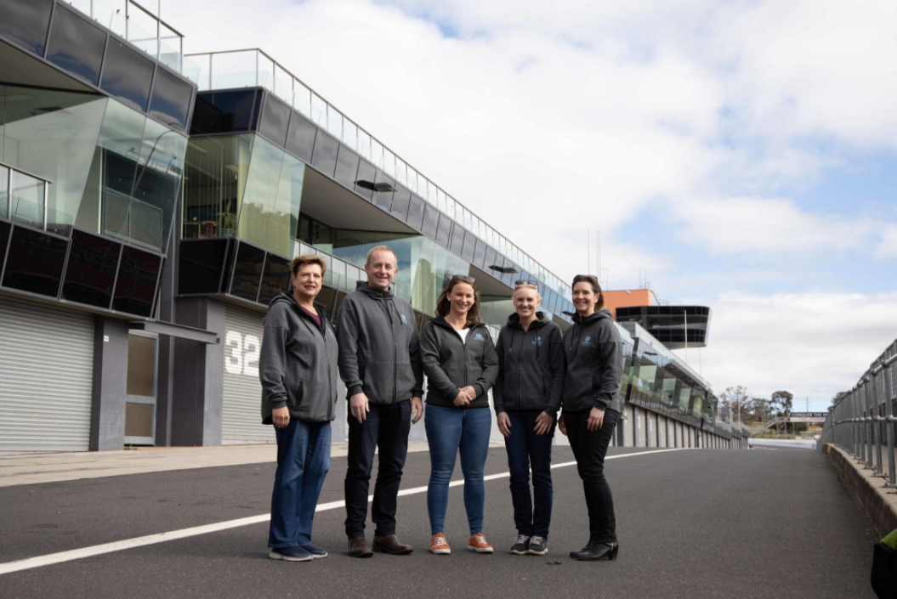

Sponsorship Application

Applicant Form

Business Name:
ABN:
Owner/s Name/s:
Business Start Date:
Business Location:
 | City | State | Postcode
Type of business, details of your industry:
How many employees do you currently have, or anticipate having in the next twelve months?

What goals do you have for your business in the next twelve months?
What do you want from your business in the next five years?
What are you biggest challenges currently?
Tell us something extraordinary about yourself and your business.
Tell us what you most desperately want from us for free in this twelve-month scholarship.

End

